QUIZ #1
How to Build a Habitable Planet
30 minutes

Name:
- Indicate which of the following statements are true or false. If false, change the statement to make it true, without making a simple negative. (24 points)

EXAMPLE:
___F___The earth is the fifth planet from the sun. – You would change “fifth” to “third”, or “The Earth” to “Jupiter”, rather than changing “is” to “is not”

Chaos theory says that prediction in non-linear systems is impossible.

The Doppler effect causes increased frequency with increasing speed of separation of source and observer.

The Big Bang was so energetic that it was able to make all the elements.

A decreasing sequence from more volatile to less volatile is rock, water, CO₂, alcohol, and vegetable oil.

Density increases with atomic number, because the size of the electron cloud gradually gets larger.

The rows of the periodic table are arranged in order of increasing number of electron shells.

Beta decay is where an atom throws out a neutron and decreases the number of nuclides in the nucleus.

Chondritic meteorites are identified by their abundance of metallic iron.

The most common form of nuclear decay is electron capture (not in the reading, so think; this requires some thought).

The fundamental building block of most minerals in the Earth and meteorites is the carbon atom.

Organic minerals are made only on planets.

Large stars are important in the Universe because they make and store the heavy elements.

- Name five (separate) characteristics of natural systems, and three examples of natural systems, each on a different scale (that is, not you, your Mom, and your best friend). Briefly compare and contrast this definition of “natural system” with a more conventional definition of “life.” We are not asking for a definition of life, just how life compares and contrasts with natural systems. (15 points).

- Explain how the following sets of elements are made in the Universe.
  - Li, Be, B
  - alpha particle nuclides (give some examples)
  - r-process nuclides (how are they different from alpha particle nuclides?)
  - s-process nuclides (how are they different from r-process nuclides?)
Be sure to answer all the parts of this question! (25 points)

QUIZ #1 –SPU-14: How to Build a Habitable Planet
30 minutes

Name: TF_______________________
- Indicate which of the following statements are true or false. If false, change the statement to make it true, without making a simple negative. (3 points each)

EXAMPLE:
___F___Earth has a density consistent with it being a very large rock. . – You would modify to “Earth has a density greater than rocks and therefore must have some denser material in its interior” rather than just saying “Earth does not have a density…”

Positive feedback takes small signals and reverses them to achieve stability.

The background radiation of the Universe confirms Olbers Paradox that in fact there is light everywhere in the Universe independent of direction.

The Big Bang was so energetic that it was able to make all the elements.

Volatility reflects the temperature at which a substance becomes a liquid or gas. For example, H₂O is more volatile than CO₂ because it turns into gas at a higher temperature.

Elements with higher atomic number are more dense than element with lower atomic number because their electron clouds are bigger.

The following shapes can all be all important elements of symmetry in minerals.

Alpha decay is where an atom throws out a neutron and decreases the number of nuclides in the nucleus.

The sequence of planets with distance from the sun is Venus, Mercury, Mars, Earth, Saturn, Uranus, Neptune, Jupiter

Only H and He are made during the Big Bang.

The fundamental building block of most minerals in the Earth and meteorites is the carbon atom.

Organic minerals are made only on planets.
- Explain the hypothesis that accounts for the differences between the inner and outer planets. First, say what these differences are; second, give the model that accounts for them. Try to be explicit about the likely compounds that make up the various planets, and why. (20 points).

- Compare and contrast small stars like our Sun with the largest stars in the galaxy. What are their relative masses? What are their relative temperatures? What are their relative lifetimes? What role does each play in allowing a habitable Universe? (20 points).

QUIZ #2 –Sci B-35: How to Build a Habitable Planet
30 minutes

Name:
- Indicate which of the following statements are true or false. If false, change the statement to make it true, without making a simple negative. (24 points)

The outer planets include more than 100 Moons of various types, some forming from “mini solar systems” and some captured.

Shoemaker-Levy is a clear example that comets remain an impact threat on Earth today, and cannot be predicted far in advance.

The late heavy bombardment on the Moon likely created all the large impact basins that we see as the “man in the Moon.”

The lunar crust is divided into three domains, the older Highlands and Lowlands, and the younger lunar Marea, which are made up of anorthosite.

Magnetic anomalies measured from ships traveling across the ocean reveal the spreading rates of the ocean floor. For faster spreading rates, the anomalies are more tightly spaced.

Wegener’s hypothesis of continental drift was finally completely verified by the discovery of plate tectonics.

Hotter mantle raises high temperatures closer to the surface, eroding the ocean crust from beneath, causing it to be thinner and at shallower depths.

Hydrous minerals in the ocean crust are formed largely at ocean ridges, and they remain carriers of water until after they have entered the subduction zone, where high pressures and temperatures at depth cause them to dehydrate.

Plate tectonics explains why all volcanism on Earth occurs in two settings, the divergent margins (ocean ridge volcanoes), and convergent margins (arc volcanoes).

For a single plate, crust going down a subduction zone will always be older than crust at a spreading center far from the subduction zone.

_____ High viscosity, low thermal conductivity, large temperature gradients and large planet size all contribute to a greater likelihood of convection.

Convergent margin volcanoes are more explosive than divergent margin volcanoes because of the high volatile contents of convergent margin magmas.

The relative age of craters in the picture below is 4, 3, 2, 1, going from oldest to youngest. “4” is the big crater. “2” is the very small crater.
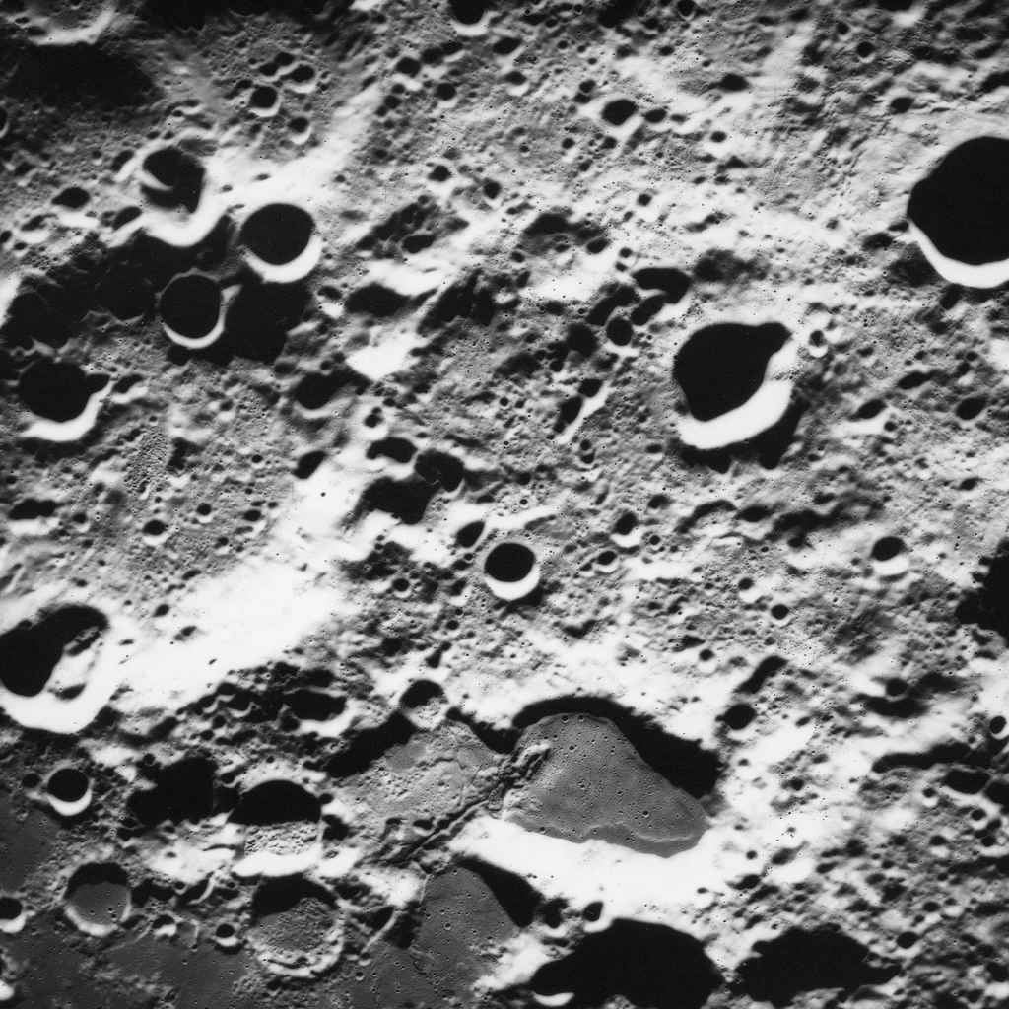
1 2
3
4

2. Explain, using examples, why oceanic spreading centers cannot be associated with the upwelling limbs of symmetrical mantle convection cells. (15 points).

3. List at least five separate and unusual characteristics of the Moon that must be explained by any successful hypothesis for the Moon’s origin. What are the three hypotheses for the Moon’s origin, and how well do each of them account for the unusual characteristics? (25 points)

QUIZ #2 –
SPU-14: How to Build a Habitable Planet

Name:
- Indicate which of the following statements are true or false. If false, change the statement to make it true, without making a simple negative. (16 points)

______Animal life at deep sea hydrothermal vents is supported by falling detritus from the surface that provides food for the hungry animals.

Melting at convergent margins is caused by volatiles added from the down-going plate to the mantle, leading to freezing point depression.

Magnetic anomalies measured from ships traveling across the ocean reveal the spreading rates of the ocean floor. For faster spreading rates, the anomalies are more tightly spaced.

Wegener’s hypothesis of continental drift was finally completely verified by the discovery of plate tectonics.

Hydrous minerals in the ocean crust are formed largely at ocean ridges, and they remain carriers of water until after they have entered the subduction zone, where high pressures and temperatures at depth cause them to dehydrate.

For a single plate, crust going down a subduction zone will always be older than crust at a spreading center far from the subduction zone.

_____ High viscosity, low thermal conductivity, large temperature gradients and large planet size all contribute to a greater likelihood of convection.

The Earth’s mantle is able to convect because addition of water converts it to a liquid allowing it to flow.

2. (a) Sketch the overall structure of a plate that contains both a continent and an ocean, extending from a spreading center. Clearly delineate the ocean crust, continental crust, mantle, lithosphere, asthenosphere, and the “plate”. (10 points)
(b) Describe in words what distinguishes ocean crust, continental crust, mantle, lithosphere, asthenosphere, and plate. (12 points).

3. Discuss the circulation of water in the plate tectonic geochemical cycle, and explain the importance it has for the operation of the Earth system. Use diagrams where you can to illustrate your answer. (25 points)

SPU-14 How to Build a Habitable Planet

QUIZ 3

Name_____________________________________ TF___________

- Here is the graph showing how carbon isotopes vary through time. What is measured to create this graph? What is the difference between the open circle data points and the triangle data points? Why is this graph important, and what does it tell us about Earth evolution?
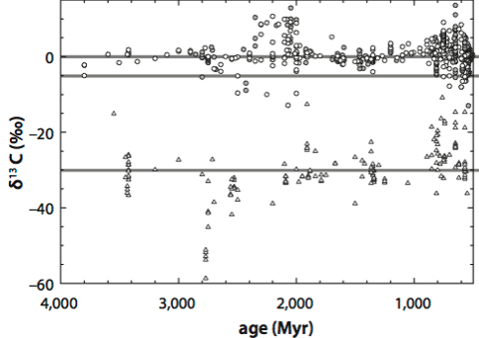

2. What are banded iron formations? When do they occur in Earth history? What is the hypothesis for their formation?

3.The Cretaceous-Tertiary boundary is a major extinction event.
(A) When did this occur?
(B) What went extinct?
(C) What were the cause(s) of the extinction, and what is the evidence for those causes?
(D) Are the causes for this extinction the same as extinctions in other parts of the geological record?

4. True-False—If the statement is false, change it to make it true without using a simple negative

_______Reduced planetary objects are likely to contain Fe in the metallic form.

______ The development of photosynthesis just prior to the Cambrian-Precambrian boundary is what led to the rise of oxygen that made complex multicellular life possible.

______ Ice age cycles have existed through Earth’s history owing to the variations in Earth’s orbital characteristics known as Milankovitch Cycles.

______ Variations in oxygen isotopes in ice or shells are used to tell us how the oxygen content of the atmosphere has varied through time.

